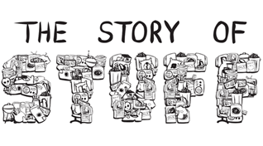

1. What are the steps in the flow chart that demonstrate how we get our ‘stuff’?

2. What is the significance of developed countries (U.S and Canada) using low and lower-middle income countries’ resources? Why do we do this? What will this cause?

3. What demographic groups are at the biggest risk for accumulating harmful toxins in their bodies?

4. What happens to the people who move out of the areas stripped for resources?

5. What does “distribution” mean?

6. How are prices kept low?

7. If the price of stuff does not reflect the true costs of its extraction and production, who pays for it?

8. What does “externalization of costs” of production mean?

9. What percentage of materials in North America is still in use six months after their date of sale?

10. Who “designed” our consumer-oriented society?

11. What seems to be the ultimate purpose of the North American economy?

12. What seems to be happening to “happiness” in North America? Why?

