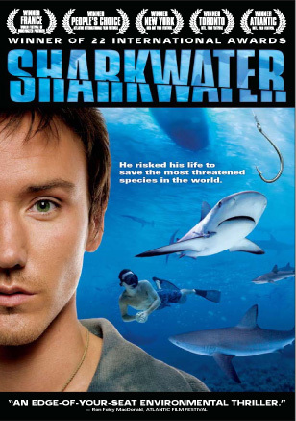
SHARKWATEr – film study

As a result of irrational and unchecked human hunting, the world’s shark population has decreased an astonishing 90%. In this true-life adventure, biologist and filmmaker Rob Stewart brings us closer to sharks than ever before. Surviving pirate boat ramming, gunboat chases, mafia espionage and battles with corrupt governments, Stewart risks his life to stop the slaughter of sharks and save our oceans and the very earth itself.

1. What percentage of the world is water? ________%

2. What percentage of life on Earth is underwater? ________%

3. Sharks have been living in the oceans for how long? ___________________ years.

4. How many years were sharks here before the dinosaurs? __________________ years

5. Sharks have been able to survive _________ of the world’s major extinctions.

6. Where in the world is one of the only places where hammerhead sharks get together in schools?
_________________ Why do they come here? ______________________________________

7. Hammerhead sharks have 2 senses than humans don’t. What are they?

(i)______________________________________________________________________
(ii)_____________________________________________________________________

8. Has a hammerhead shark ever attacked a human? __________

9. Complete this sentence: “When life in the ocean changes, so too does life _________________________”
_________________________________

10. Are the majority of shark bites deadly? _______________

11. Sharks kill _______ people per year.

12. a) Elephants and tigers: ________

b) Illegal drugs: _______________

c) Road accidents: _______________

d) Starvation: __________________

13. ______________ are protected in the oceans, but not all sharks.

14. What is another word for ‘poaching’? _____________________

15. Describe what ‘long-lining’ looks like? (long-lining is how humans catch sharks)
_______________________________________________________________________________________________________

16. Why is long-lining harmful?
__________________________________________________________________________________________________________

17. Why are sharks killed? For their ______________.
18. These are put into what kind of food? _____________ ________ ___________

19. Why do you think humans have been slow to protect the lives of sharks?
__________________________________________________________________________________________________________

20. How many sharks have been killed while we’ve been watching the film? _______________

21. Are shark fins a natural resource? _________ Explain your answer.
__________________________________________________________________________________________________________
_____________________________________________________

Shark Finning – Why (and how) is this a geographic issue?

(i) Is shark finning a concern to many people? If so, who? And why?

(ii) Does shark finning have different perspectives (or sides)? If so, identify the perspectives.
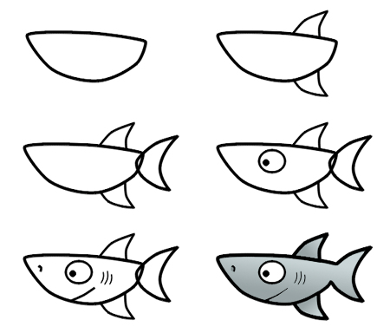
(iii) Are some of the perspectives in dispute with other perspectives? If so, how?

(iv) Is a solution required? If yes, explain some possible solutions.

