Nature vs Nurture in Psychology

This debate within psychology is concerned with the extent to which particular aspects of behavior are a product of either inherited (i.e. genetic) or acquired (i.e. learned) characteristics. Nature is what we think of as pre-wiring and is influenced by genetic inheritance and other biological factors. Nurture is generally taken as the influence of external factors after conception, e.g. the product of exposure, experience and learning on an individual. The nature-nurture debate is concerned with the relative contribution that both influences make to human behavior.
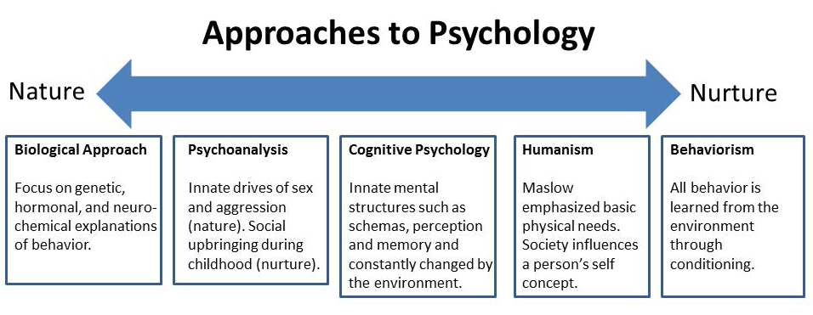
It has long been known that certain physical characteristics are biologically determined by genetic inheritance. Color of eyes, straight or curly hair, pigmentation of the skin and certain diseases (such as Huntingdon’s chorea) are all a function of the genes we inherit. Other physical characteristics, if not determined, appear to be at least strongly influenced by the genetic make-up of our biological parents.

Height, weight, hair loss, life expectancy and vulnerability to specific illnesses (e.g. breast cancer in women) are positively correlated between genetically-related individuals. These facts have led many to speculate as to whether psychological characteristics such as behavioral tendencies, personality attributes and mental abilities are also “wired in” before we are even born.

Those who adopt an extreme hereditary position are known as nativists. Their basic assumption (theory) is that the characteristics of the human species as a whole are a product of evolution and that individual differences are due to each person’s unique genetic code. In general, the earlier a particular ability appears, the more likely it is to be under the influence of genetic factors.

Nativists argue that characteristics and differences that are not observable at birth, but which emerge later in life, are regarded as the product of maturation (getting older). That is to say we all have an inner “biological clock” which switches on (or off) types of behavior in a pre- programmed way. The classic example of the way this affects our physical development are the bodily changes that occur in early adolescence at puberty. However, nativists also argue that maturation governs the emergence of attachment in infancy, language acquisition and even cognitive development (how we learn) as a whole.

At the other end of the spectrum are the environmentalists – also known as empiricists (not to be confused with the other empirical / scientific approach). Their basic assumption is that at birth the human mind is a tabula rasa (a blank slate… sound familiar?) and that this is gradually “filled” as a result of experience (e.g. behaviorism).
From this point of view psychological characteristics and behavioral differences that emerge through infancy and childhood are the result of learning. It is how you are brought up (how you are nurtured) that governs the psychologically significant aspects of child development and the concept of maturation applies only to the biological.
For example, when an infant forms an attachment, it is responding to the love and attention it has received, language comes from imitating the speech of others and cognitive development depends on the degree of stimulation in the environment and, more broadly, on the civilization within which the child is reared.

Examples of an extreme nature position in psychology include Bowlby's (1969) theory of attachment, which views the bond between mother and child as being an innate process that ensures survival. Likewise, Chomsky (1965) proposed that language is gained through the use of an innate language acquisition device. Another example of nature is Freud's theory of aggression as being an innate drive (called thanatos).

In contrast Bandura's social learning theory states that aggression is learnt from our environments through observation and imitation. This is seen in his famous Bobo doll experiment (Bandura, 1961). Also, Skinner (1957) believed that language is learnt from other people via behaviour-shaping techniques.

In practice, hardly anyone today accepts either of the extreme positions. There are simply too many “facts” on both sides of the argument which are inconsistent with an “all or nothing” view. So instead of asking whether child development is down to nature or nurture the question has been reformulated as “How much?” That is to say, given that heredity and environment both influence the person we become, which is the more important?

Let’s try to apply the nature vs. nurture debate to a contemporary issue we face in our society.
Q: Are we born with a neutral gender identity?

**Note: The term "gender identity disorder" was once a diagnosis listed in the American Psychiatric Association's Diagnostic and Statistical Manual of Mental Disorders, a book of classifications of mental disorders widely used by American mental health professionals.
That old diagnosis meant that a man who believed he was destined to be a woman was considered mentally ill.
The most recent edition of this manual, the DSM-5, eliminates the term "gender identity disorder," which was long considered stigmatizing by mental health specialists and LGBT activists.
The new DSM refers only to "gender dysphoria," which focuses the attention on only those who feel distressed by gender identity issues. Having this still available as a diagnosis ensures a transgender person can still access related health care if needed. Hormone treatment would be one example. Another would be counselling for those who need help dealing with their emotions.

Nature vs. Nurture Debate
Are we born gender ‘neutral’?

In your own words, explain the difference between sex and gender.
____________________________________________________________________________________________________________________________________________________________

Reflection: As you were being raised, how were you ‘gendered’ by your environment/surroundings? In other words, how were you ‘boxed’ to be a boy or a girl?

How are you being ‘boxed’ at this point in your life? Explain, with the use of examples.

In what ways does the education system (e.g. Acton High School) ‘box’ students into specific gender roles? So, for example, would a student who identifies as ‘gender neutral’ feel comfortable and safe attending our school? (note: the presence of a gender neutral washroom does not necessarily = a ‘safe’ school environment)

Is our society too preoccupied with gender binaries? Is gender a necessary social construct?

