Name: _________________________________ Date: ______________________

THE LORAX
BY: DR. SEUSS

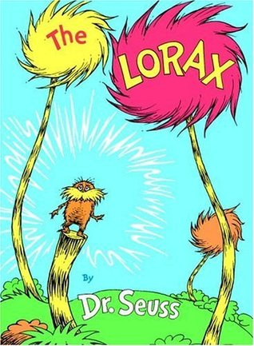
1. What begins to happen to the Truffula Trees?
________________________________________
________________________________________

2. Who is the Lorax.
________________________________________
________________________________________

3. Who is Once-ler?
________________________________________
________________________________________

4. What is Thneed?
____________________________________________________
____________________________________________________

5. Describe how the production of Thneeds changed the natural world. Use 3 examples.
____________________________________________________
____________________________________________________
____________________________________________________
____________________________________________________
____________________________________________________

6. What does the Lorax show Once-ler about the damage his business is doing to the natural world? Use 3 examples.
____________________________________________________
____________________________________________________
____________________________________________________
____________________________________________________
____________________________________________________
____________________________________________________

7. What happens to the Truffula Trees?
____________________________________________________
____________________________________________________

8. Define the meaning of “Unless.”
____________________________________________________
____________________________________________________

9. What happens to the last Truffula Tree seed?
____________________________________________________
____________________________________________________
____________________________________________________

10. What do each of the following symbolize (or represent) in our society today?

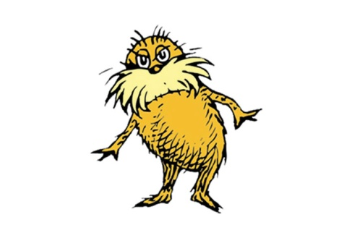
Truffula Trees: _______________________________________

The Lorax: _______________________________________

Thneed: _______________________________________

Once-ler: _______________________________________

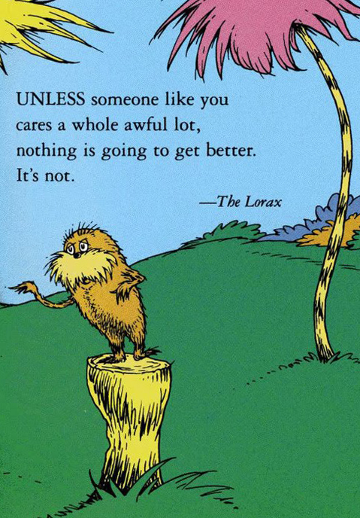
11. Read the famous quote on the side. Rephrase his message so that it is in your own words… and use the word ‘stewardship’ and ‘sustainability’.
_________________________________
_________________________________
_________________________________
_________________________________
_________________________________
_________________________________
_________________________________
_________________________________
_________________________________

