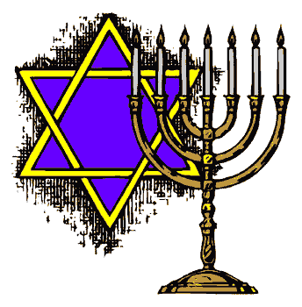
Major Beliefs of Judaism
First and foremost, it is essential that we realize the word ‘Jew’ is used to identify someone who practices Judaism. The original name for the people that we now call Jews is Hebrews (according to Jewish tradition, the name derived from one of Abraham’s descendants). It is also possible that the term Hebrew comes from the word “ever,” which translates into “the other side.” This would make sense also, as it may refer to the fact that Abraham preached a message that was very different from the rest of Mesopotamian society (he preached monotheism as opposed to polytheism).

The word “Jew” itself is derived from the name “Judah,” who was one of Jacob’s sons (Jacob was the grandson of Abraham). The use of the term itself dates as far back as the 6th century BCE.

Today, a Jew is a person who is born Jewish or converts to Judaism. Jewish tradition is matrilineal, meaning that if a child’s mother is Jewish, then the child is born Jewish. Although the Torah does not explicitly state this fact, it is considered to be implied in various parts of the Torah. Today, some Jews consider a child Jewish if either one of the parents is Jewish.

As mentioned, if people are sincere about their beliefs, they can convert to Judaism in a process known as gerut. This is the only way a non-Jew can become a Jew. The conversion is marked by a formal oral or written examination.
Essentially, most believe that there are three basic principles of the Jewish faith: God, the Torah, and Israel (the promised land).

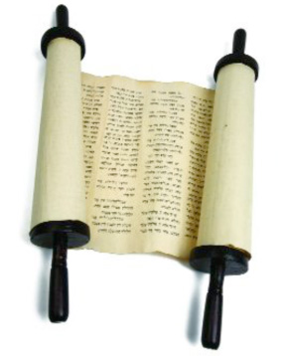
What Do Jews Believe About God?
Quite simply, Jews believe in one, all-powerful, all-knowing God. There is nothing that happens without God. Perhaps the best way to summarize this belief is in the statement, “God is One.”

The Torah is the Jewish sacred text. It is sometimes referred to as the Hebrew Bible. It includes the five books of Moses (Genesis, Exodus, Leviticus, Numbers, Deuteronomy), the Ten Commandments, and the 613 mitzvoth (see below). The word ‘Torah’ means ‘to teach.’
Jewish belief in God may best be highlighted by two essential teachings: The Five Fundamental Concepts and the Thirteen
Articles of Faith.

The Five Fundamental Concepts
- There is a God.
- There is only one God.
- God created the world, but it will not last forever.
- There is only one universe
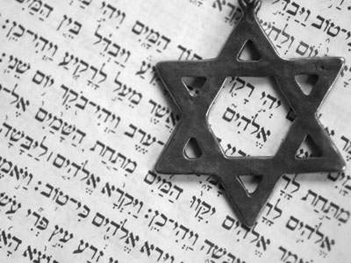
- God cares for the world and all of its creatures.
The Thirteen Articles of Faith
1. God exists.
2. God is one and unique.
3. God is incorporeal.
4. God is eternal.
5. Prayer must be directed to God alone.
6. The prophets spoke the truth.
7. Moses was the greatest of the prophets.
8. The Torah was given to Moses.
9. There will not be another Torah.
10. God knows the thoughts and actions of people.
11. God will reward the good and punish the wicked.
12. The Messiah will come.
13. The dead will be resurrected.

G-D: male or female?
It is important to note that Jews believe that God does not have a physical form. Any reference to God inferring the use of a body part is simply to allow us to comprehend His actions. To put God into a physical form would be idolatry. This is why God cannot have a gender.
Did You Know?
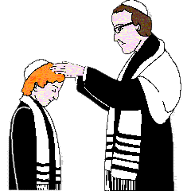
Jews take special care to observe the sacredness of God when writing His name. Contrary to popular belief, Judaism does not prohibit the writing of God’s name, but erasing or defacing the name of God is strictly forbidden. That is why you will see the use of “G-d” in most Jewish texts and websites … just in case in will ever need to be erased!

The Messiah
Jews believe that God will send a Messiah to restore peace on earth. The Messiah’s arrival will make God’s existence clear to all and will not only be marked by the restoration of the Temple in Jerusalem, but also by the establishment of God’s Kingdom on earth. Jews believe that Jesus was not the Messiah because violence and war continues to mark history since his death.
In closing, it is clear that Jews believe that God is everything! Perhaps the Jewish belief in God can best be summarized by the Shema, the Jewish creed of faith, which states, “The Lord is our God, the Lord is One.”

What does it mean to be Jewish?
Many people ask the question, “What does it really mean to be religious?” The answer can sometimes be complex and confusing. However, the real answer is that being a member of a particular faith system requires you to show your beliefs through the way in which you conduct yourself.

Think of the often quoted phrase, “Don’t just talk the talk…walk the walk!” What this is really trying to say is, “Show me” or “Prove it.” For practicing Jews, honouring God is demonstrated not only through every day actions, but in special practices that are unique to the religion itself.
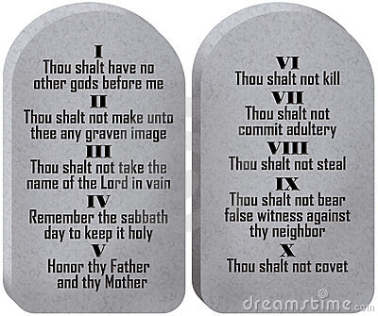
Quite simply, the ways in which Jews are to conduct themselves is found in the Bible. Jewish tradition teaches that the Bible contains 613 mitzvoth (singular - mitzvah). 248 of the mitzvoth are considered “positive” or actions that should be taken, while there are 365 negative mitzvoth which should be avoided. Jews believe that by performing or not performing a mitzvah, they are not only living properly, but demonstrating their belief in God.

10 examples of ‘do’ mitzvoth | 10 examples of ‘don’t’ (negative) mitzvoth
- Know there is a God.  - Love other Jews.  - Learn the Torah.  - To repent and confess wrongdoings.  - To have children with one’s wife.  - To distinguish between kosher and non-kosher.  - To give to charity.  - To honour those who teach and know the Torah.  - To rest on the seventh day.  - Show reverence to the Temple. | - Not to embarrass others.  - Not to oppress the weak.  - Not to inquire into idolatry.  - Not to tattoo the skin.  - Not to marry non-Jews.  - Not to cut his hair.  - Not to murder.  - Not to strike your mother or father.  - Not to follow the whims of your heart or what your eyes see.  - Not to withhold food, clothing, or sexual relations from your wife.
Following God’s commandments is an essential part of Judaism. It is the way in which Jews keep their covenant with God.

The synagogue, quite simply, is the centre of the Jewish religious community and the communal home of worship. For Jews, the synagogue, along with the family home, is the center for learning about the faith. These beliefs help explain why some Jews refer to the synagogue as “Shul,” which is derived from the German word for “school.”
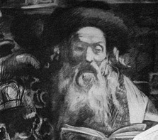
Most synagogues have a rabbi to lead religious rituals and tend to the needs of the religious community. A rabbi is most often educated in Jewish law and thus able to settle religious disputes. It is not essential for a synagogue to have rabbi as they do not have more power than other male members.

Although practices vary, the Torah is usually read on Mondays, Thursdays, Sabbaths, and some holidays. There is a different Torah reading for each week of the year. The Torah is divided in to 54 sections and two weeks of the year have a double portion.

Traditionally, the Torah is written on a scroll that is then wound around two wooden poles. This is called a “Sefer Torah” and it is handwritten by a sofer (scribe) who must copy the text perfectly. The Sefer Torah is considered to be the most sacred object in Jewish life and is kept in a cupboard called the “Aron hakodesh,” or “Holy Ark”. The Ark is attached to the wall of the synagogue that faces Jerusalem. The Sefer Torah must never be touched because it must be respected and it is written on parchment, which is very delicate. A pointer is used as a guide when reading it, and Jews consider it a great honour when invited to read from it.

Daily prayer is an essential part of Jewish worship. There are three prayer times - in the morning, afternoon, and evening. Tradition teaches that the day begins and ends with sunset, and the evening prayer is considered to be the first prayer of the day. The oldest daily prayer is the Shema. Jewish prayers are based around the concept of “blessing.”

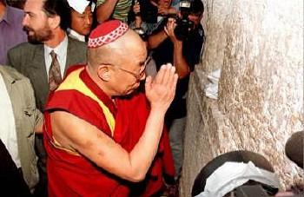
There are three main types of blessings:
- to God, for the five senses,
- a thanks for honouring the mitzvoh, and
- to honour God.
Certain traditions and customs also shape the physical look of prayer. Men usually wear a skull cap known as a “yarmulke,” especially during prayer, while a woman who is or was married will wear a head scarf (or wig, or half wig) known as a “sheitel.” These coverings may be worn outside of prayer times.

Sabbath
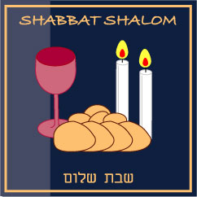
The honouring of the Sabbath (Hebrew name Shabbat) is arguably the most important ritual of the Jewish people. Jewish tradition teaches that God rested on the seventh day after creating the heavens, the earth, and everything in them. The Jewish Sabbath is Saturday. On this day, not only are Jews prohibited from working, they must put aside almost everything including sports, driving, cooking, shopping, and even schoolwork. It is a time to focus on prayer and family.

A typical Sabbath honouring would begin on Friday evening. Remember the Jewish day starts at sunset. The beginning of the Sabbath is marked by the woman of the house lighting two candles which marks the teaching of the creation story: “Let there be light.” The family will go to the synagogue for the service, and upon return to the home, have a special dinner that is marked by prayer, challah, and wine. The following morning is spent at the synagogue, where the Shabbat service can last up to three hours. The rest of the day is spent focusing on Torah study and quality family time. The day is closed at sunset with prayers.
Jewish culture
An important part of the Jewish faith revolves around food. Jewish dietary laws are known as "Kashrut," which means proper or correct. The term kosher refers to food that is permissible to eat. Most fruits and vegetables are kosher, but many animals are not. A kosher animal must have hooves that are divided in two and chew the cud. It must also be killed by "Shehitah," meaning that its throat is cut and the blood drained from its body. Many believe that this practice dates back thousands of years and may link to the fact that many animals at that time carried significant forms and levels of diseases.

Milestones
A person that is Jewish will reach certain religious milestones through their life. These milestones are often referred to as “rites of passage,” and are important in the sense that they offer a new experience within the religious tradition or celebrate an event in a way that honours his or her belief.

If a person is Jewish, here are some of the milestones or rites of passage they will experience:

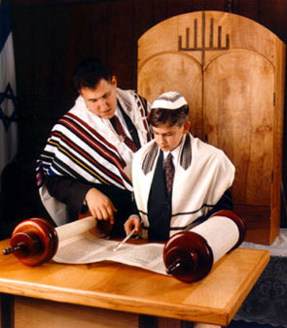
1. A Jewish baby will be given two names: a conventional name that they will be known as in their day-to-day life, and a traditional Hebrew name that will be used in religious rituals. A girl’s name will be given at the synagogue on a Sabbath day shortly after birth while a boy will receive his name during the brit milah, or ritual circumcision. Circumcision is considered to be the first commandment given specifically for Jews and is a physical expression of the covenant between man and God. This ceremony takes place on the eighth day of the boy’s life and is traditionally performed by a mohel,who is trained according to Jewish law.

2. The “coming of age” is an important moment in Jewish life and represents the acknowledgement that a person is now obligated to observe the commandments. This is marked by the “bar mitzvah” or “Son of the Commandment” for boys, held at the age of 13, and the “bat mitzvah” or “Daughter of the Commandment” for girls, held at the age of 12. A ceremony is usually held to mark this event, but one is not necessary as practicing the Torah is seen as an obligation of Jewish life.
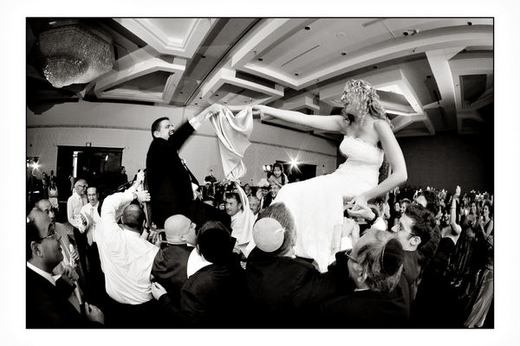

3. Marriage is a very important part of Jewish life because of the importance placed on family within the belief system. Jews believe that not marrying is unnatural. Most weddings take place in a synagogue, and the bride and groom usually fast the day before the wedding. The ceremony is marked by two interesting events - the signing of the marriage contract, and the groom crushing a glass under his foot.

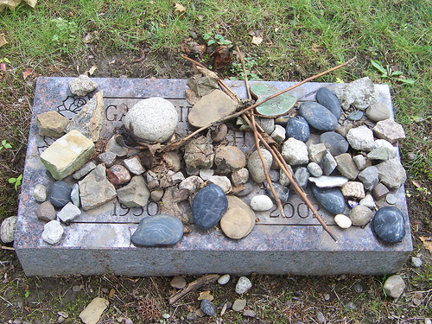
4. Death is seen as part of God’s divine plan and is marked by a mourning period known as Shiva. In the home of the deceased, family mourners will gather for seven days to honour the loss. A special mourning period is reserved for the parents, known as “avelut.” During this twelve month period, a parent must avoid celebratory events such as parties.
Stones are placed on Jewish gravestones as an ultimate sign of kindness and respect. This is done to indicate our participation in the mitzvah of erecting a tombstone, even if only in a more symbolic way.

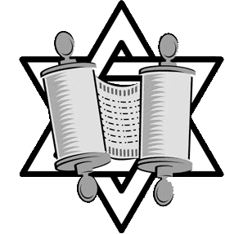
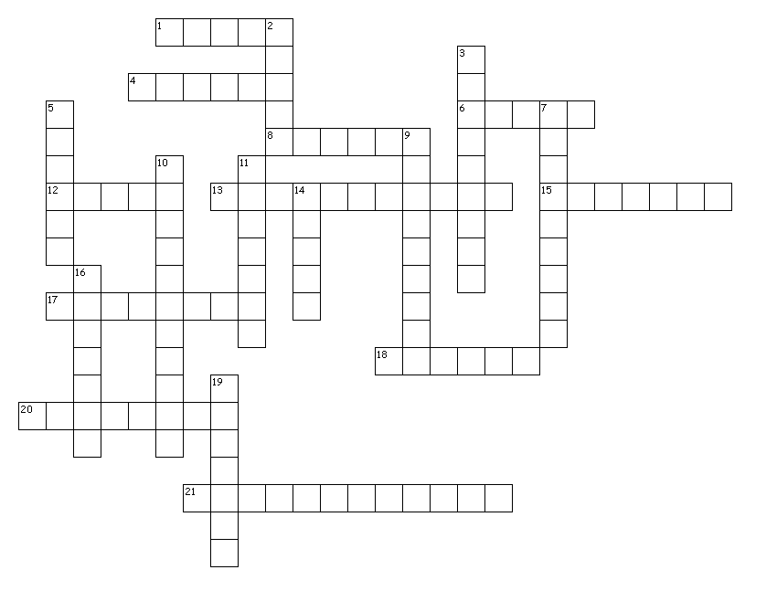
MAJOR BELIEFS OF JUDAISM

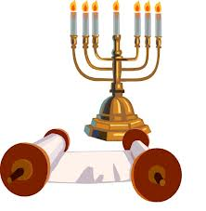

ACROSS
1. The process by which someone converts to Judaism.
4. Food that is permissible to eat by Jewish law.
6. Leader of religious rituals in synagogues.
8. A kosher animal must have _______ that are divided in two.
12. The time of mourning for those who have lost a loved one.
13. If a child’s mother is Jewish, then the child is born Jewish.
15. To give to charity is an example of a positive __________.
17. The contract that exists between God and humanity.
18. At a Jewish wedding, the groom crushes a glass under his foot to symbolize the destruction of the __________.

20. The cap worn on the top of a man’s head to symbolize that G-d is always above him.
21. This rite of passage will take place during the 8th day of a boy’s life.

DOWN
2. Also referred to as the Hebrew Bible.
3. In each synagogue around the world, the holy ark faces this city.
5. Jewish tradition teaches that the day begins and ends at this time.
7. Coming of age celebration for a young girl.
9. House of worship for the Jewish community.
10. The western wall is also referred to by this name.
11. The most important ritual of the Jewish people.
14. These are placed on a Jewish tombstone as a sign of respect.
16. The sacred sefer torah is stored in here.
19. Many Jews believe that the _________ will come to restore peace earth

