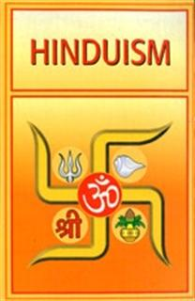
HINDUISM REVIEW
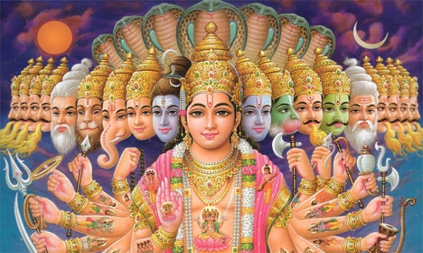
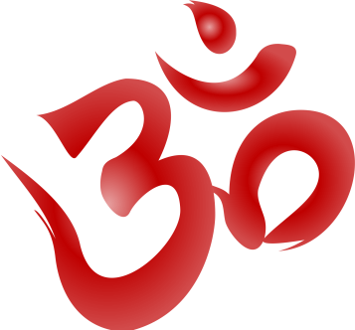
Across

3. A man who gives up material life to achieve salvation.
5. This deity is considered to be the creator of the universe.
9. Sacred animal: loved for all that it provides.
10. Also called the Hindu Trinity.
11. Hinduism’s earliest sacred writings.
14. The destroyer and restorer of the universe.
17. Those who fall outside of the 4-part caste system.
19. “I have a sense of déjà vu.”
20. One of the holiest rivers for Hindus.
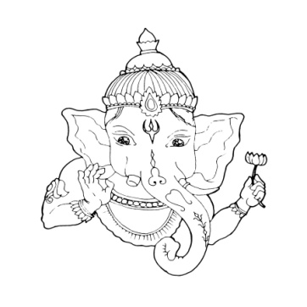
22. The temporary/imperfect nature of the physical world.
23. Worship of many gods.

Down

1. The universal soul and supreme being.
2. One of the holiest cities for Hindus.
4. Continuous cycle of births and rebirths.
6. Worship on one god.
7. Someone of the highest Hindu caste.
8. A sacred syllable that invokes the essence of Brahman when chanted.
11. The preserver of the universe.
12. Moral or religious duty.
13. Ritual involves offerings of food and flowers to deities.
15. Also referred to as your soul; identical to the universal soul.
16. Release from the cycle of birth and rebirth.
18. What goes around comes around.
21. A religious leader that can guide you to salvation.

