ARE “HAPPY” MEALS REALLY HAPPY FOR THE EARTH??

1. Practicing sustainability is a way of living that does not negatively affect the ability of future generations to meet their needs. Do Happy Meals allow us to do this?

For this section:

- Draw an arrow from each box to a piece of the Happy Meal that is not sustainable.
- For each arrow, identify what you are pointing to.
- Explain in a sentence or two why it is not sustainable.

What?_______________________________

Why? ________________________________ ____________________________________________________________________________________________________________________________

What?_______________________________

Why? ________________________________ ____________________________________________________________________________________________________________________________

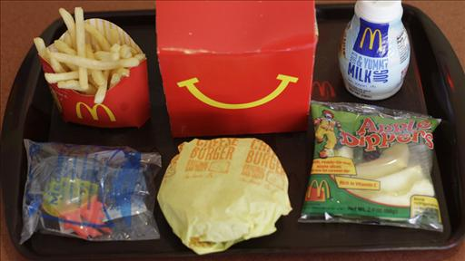
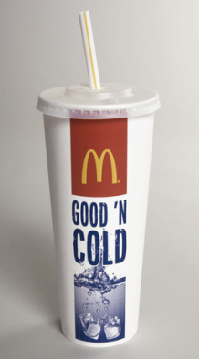

What?_______________________________

Why? ________________________________ ____________________________________________________________________________________________________________________________

What?_______________________________

Why? ________________________________ ____________________________________________________________________________________________________________________________

2. Now that you’ve identified 4 unsustainable characteristics of a Happy Meal, it’s time to dig a little deeper:
How can we create a “Happy” Meal that is sustainable?

In the spaces below, identify four suggestions that would make a “Happy Meal” sustainable AND help to shrink your Ecological Footprint (your impact on the Earth).

Suggestion #1
____________________________________________________________________________________________________________________________________________________________________________________________________________________

Suggestion #2
____________________________________________________________________________________________________________________________________________________________________________________________________________________

Suggestion #3
____________________________________________________________________________________________________________________________________________________________________________________________________________________

Suggestion #4
____________________________________________________________________________________________________________________________________________________________________________________________________________________

1. “Happy Meal”? – Evaluation (Question 1):

Criteria | Level 1 | Level 2 | Level 3 | Level 4
You apply the concepts of sustainability in the context of a Happy Meal by identifying objects and practices that are not sustainable.  /5 (App) | You apply the concepts of sustainability in the context of a Happy Meal with limited effectiveness. | You apply the concepts of sustainability in the context of a Happy Meal with some effectiveness. | You apply the concepts of sustainability in the context of a Happy Meal with considerable effectiveness. | You apply the concepts of sustainability in the context of a Happy Meal with a high degree of effectiveness.
You evaluate how specific objects and practices in the Happy Meal do not promote sustainability.  /5 (Think) | You evaluate how specific objects and practices do not promote sustainability with limited effectiveness. | You evaluate how specific objects and practices do not promote sustainability with some effectiveness. | You evaluate how specific objects and practices do not promote sustainability with considerable effectiveness. | You evaluate how specific objects and practices do not promote sustainability with a high degree of effectiveness.
Clear expression and organization of ideas.  Attention to spelling, grammar, and punctuation.  /5 (Comm) | Your responses are communicated with limited effectiveness. | Your responses are communicated with some effectiveness. | Your responses are communicated with considerable effectiveness. | Your responses are communicated with a high degree of effectiveness.

2. “Happy Meal” Suggestions – Evaluation (Question 2):

Criteria | Level 1 | Level 2 | Level 3 | Level 4
Connections are made between how sustainable practices can shrink the size of an individual’s ecological footprint.  /5 (App) | Connections are made with limited effectiveness. | Connections are made with some effectiveness. | Connections are made with considerable effectiveness. | Connections are made with a high degree of effectiveness.
You use critical/ creative thinking processes to create ideas that promote more sustainable practices.  /5 (Think) | You use critical/ creative thinking processes with limited effectiveness. | You use critical/ creative thinking processes with some effectiveness. | You use critical/ creative thinking processes with considerable effectiveness. | You use critical/ creative thinking processes with a high degree of effectiveness.
Clear expression and organization of ideas.  Attention to spelling, grammar, and punctuation.  /5 (Comm) | Your responses are communicated with limited effectiveness. | Your responses are communicated with some effectiveness. | Your responses are communicated with considerable effectiveness. | Your responses are communicated with a high degree of effectiveness.

