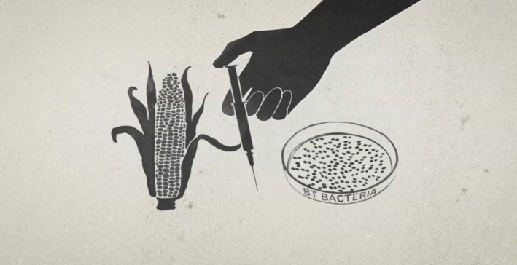
GMO – OMG!

Name: ____________________________

1. What does GMO stand for? _________________________________________________

2. Who/What is Monsanto? (can you make a connection to the Onceler?)
________________________________________________________________________________________________________

3. Explain why poor, rural Haitian farmers burned the seeds that were donated by Monsanto after the devastating earthquake?
________________________________________________________________________________________________________

4. If something is not labeled as ‘ORGANIC’, then it is most likely ___________

5. What percentage (%) of processed foods contains GMO’s? _____________

6. What does “ALL NATURAL” mean on food labels?
________________________________________________________________________________________________________

7. What _______% of corn in the United States is GM?

8. True or False. There are more prisoners in the United States than there are farmers? _______

9. A farmer cannot “save seeds” to replant because the seeds are “patented.” What does this mean? Explain in your own words.
________________________________________________________________________________________________________
________________________________________________________________________________________________________

10. Are GM foods ‘safe’ for human consumption?
________________________________________________________________________________________________________
11. Why do some people want to avoid GM foods?
________________________________________________________________________________________________________

12. What is the “Precautionary Principle” mentioned in the film?
________________________________________________________________________________________________________

13. In the chart below, record information for each side of the GMO debate as you watch the movie.

Positive Aspects of GMO’s | Negative Aspects of GMO’s

14. Do you think Canada should make it law that food labels include information about GMOs?
In other words, do you have a right to know what is in your food?
________________________________________________________________________________________________________
________________________________________________________________________________________________________________________________________________________________________________________________________________
________________________________________________________________________________________________________
________________________________________________________________________________________________________

