GLOBAL WARMING ‘MIND MAP’

The burning of fossil fuels (a non-renewable resource) has led to a major global issue: Global Warming, also known as Climate Change.
To help you to organize the information that you are learning and to add to your growing knowledge, you will construct a loverly ‘mind map’. We will discuss how to do this in class.

Mind maps present your information visually and have common elements:
- The central image and subject being mapped is located in the centre.
- Detailed themes, ideas or concepts radiate out from the central idea.
- Connectors branch ideas from the themes together.
- Visuals and colour to clarify the information presented.
- Words to identify main ideas or concepts.
- The more information you can include, the better.

Use the following as a guide to know what to include (and where) on your map:
- Place ‘Global Warming’ in the center of your map.

- Subheadings could include:

  - What is global warming?
    - Greenhouse effect
    - What causes global warming?
    - Facts about global warming

  - Why is global warming an issue?
    - Use your note to include the 4 criteria

  - Impacts of global warming (each can be a subheading)
    - Facts and information about each of the impacts
Resources Include:
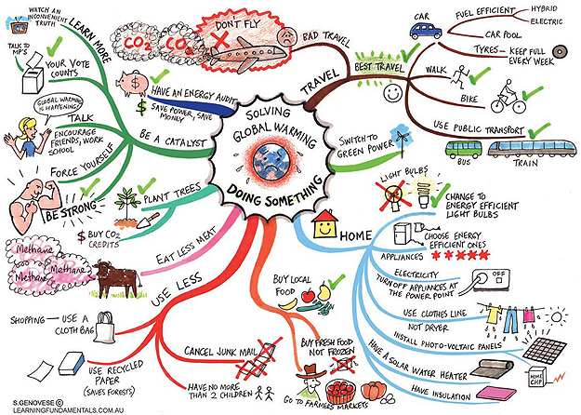
- The course textbook – pp. 495-497
- Library books
- Internet websites (World Wildlife Fund, Live Science, David Suzuki)

Rubric for Global Warming Mind Map
Name:

Performance Indicators
Criteria | Level 1 | Level 2 | Level 3 | Level 4
Central Image  / 5  (Thinking) | Not clear; difficult to separate from other information on the mind map. | Present; not eye catching or memorable. Not really linked to global warming. | Clear; use of picture or image relates to global warming. | Stands out; meaningfully grasps global warming.
Ideas radiate out from the central image and from most to least complex  / 5  (Application) | Little or no indication that ideas are connected to and radiating out from centre, from most to least complex. | Ideas radiate out from centre, some confusion as you follow ideas moving from most to least complex. | Ideas clearly connect to central image and ideas, and for the most part move from most to least complex. | Ideas clearly connect to central image and ideas consistently and accurately shift from most to least complex.
Ideas have key images or key words  / 10  (Thinking) | Little or no evidence of key images. May have a few keywords or vice-versa. | Images and keywords are evident, but either too few or imprecise. | Images and keywords clearly show an understanding of the content, although not memorable. | Dynamic use of images and keywords. They clearly connect to central image. See use of metaphor, humour, cut-outs from magazines, clipart, etc.
Colour or codes or links are used to illustrate connections between ideas  / 5 (Communication) | Little to no use of colour, codes or links to illustrate connections between ideas | Obvious attempt is made to use colour, codes or links to enhance clarity and memory. Still a bit confusing. | Clearly uses colour, codes or links to clarify connections and to assist with memory for most aspects of Mind Map | Effectively uses colour, codes, or links to meaningfully clarify connections for all aspects of Mind map
Depth of coverage  / 15  (Knowledge) | Insufficient coverage of content covered. Very little effort is made. | Shows a basic level of coverage of key ideas but little extension of ideas. | Shows a solid grasp of most of the content and shows extensions of most key ideas. | Shows a solid grasp of all the content covered. Extensions of the key ideas show a deep understanding of that content.

Mark: / 40

