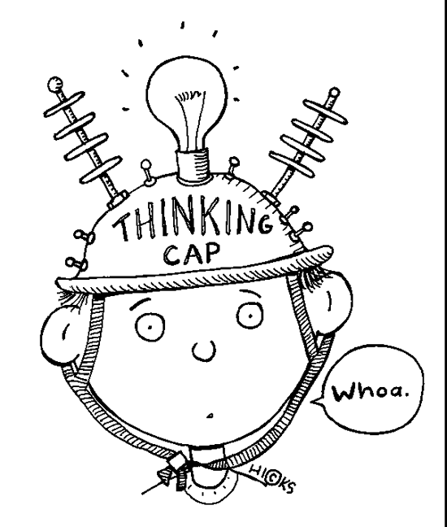
Forces of CULTURAL CHANGE

What is culture?
The norms, values, practices, patterns of communication, language, laws, customs, and meanings shared by a group of people located in a given time and place.
Ok, but how do we know these ‘norms’?

Remember… forces of socialization: our systematic training into the norms of our culture (think back to the documentary we watched about the Amish in Lancaster, Pennsylvania). Socialization is the process of learning the meanings and practices that enable us to make sense of and behave appropriately in that culture.

Sources of Cultural Change
Cultures are always changing, but why do they change?
Clashes between ideology and reality cause: tension and crisis which then need to be resolved.

Anthropologists generally consider these sources of major change in cultures:

1. Discovery – something previously unknown (flint makes fire! the earth is not flat)
2. Invention – new ideas and products (gender roles, human rights, penicillin, nuclear fission)
3. Diffusion – new ideas and technology spreading through cultures

When you put discovery, invention and diffusion together, we get … Innovation: the process of making improvements by introducing something new.
You can call this Diffusion of Innovation – this is how we change.
Diffusion: new ideas and technology spreading through cultures.

Everett Rogers proposed a five-stage model for the Diffusion of Innovation:

(i) Knowledge – learning about the existence and function of the innovation

(ii) Persuasion – becoming convinced of the value of the innovation

(iii) Decision – committing to the adoption of the innovation

(iv) Implementation – putting it to use

(v) Confirmation – the ultimate acceptance (or rejection) of the innovation

One of the main forces for social/cultural change is charismatic leadership. These individuals have large vision, magnetic style and popular support. Examples have charisma, vision, and ‘truth’ … :
MLK, Gandhi, Hitler, Che Guevera, Chairman Mao, Obama, Angela Merkel, Muhammad, Christ, Dalai Lama, Steve Jobs, Oprah, Princess Diana, Mark and Craig Kielberger … and maybe even … Donald Trump?

Your task:

Today and tomorrow, you will work in assigned groups to define one of the terms that are
Forces of Cultural Change.

Here’s the list of forces:

(i) Contact – Brendan, Skylar, Hannah, Avry
(ii) Deviance – Humber, Priscilla, Blake, Taylor S.
(iii) Alienation- Danielle, Sydney B., Kailey , Taylor W.
(iv) Charismatic Leadership – Amanda, Makaila, Joey
(v) Technology Evolution – Austin, Amy, Devon
(vi) Globalization – Sydney H., Ashley, Shaela
(vii) Pluralism – Spencer, Sarah, Roxanne
(viii) Traditional Cultural Values – David, Diana, Makayla

In your groups, please do the following with the ‘force’ your group has been assigned:

1. Provide an explanation of the force in your own words (minimum of 7-10 sentences – enough to give someone who has never heard of the concept a good understanding).

2. Using real world examples, explain how your force has helped with social change somewhere in the world. Explain how this has been a positive and/or negative change for the people affected.

3. Using real world examples, explain how your force has acted as a barrier to social change somewhere in the world. Explain how this has been a positive and/or negative change for the people affected.

Create a google doc or a presentation that will be shared with the class. Your peers will be taking notes on the force that you present (don’t worry … you can present from your seats like we did for the dominant paradigms). All of these concepts will be on the final exam.

** You must include a minimum of 3 research references, listed APA style, at the end of your work.

You clearly explain your force of cultural change with the use of timely, relevant examples (as per instructions).  /20 | Your force of cultural change is explained with limited effectiveness. | Your force of cultural change is explained with some effectiveness. | Your force of cultural change is explained with considerable effectiveness. | Your force of cultural change is explained with a high degree of effectiveness.
You communicate and express ideas and information (spelling, grammar, organization)  (Communication)  /10 | You express and organize ideas and information with limited effectiveness | You express and organize ideas and information with some effectiveness | You express and organize ideas and information with considerable effectiveness | You express and organize ideas and information with a high degree of effectiveness
A bibliography page has a minimum of 3 references – cited using APA format.  /5 | You cite work using APA referencing style with limited effectiveness. | You cite work using APA referencing style with some effectiveness. | You cite work using APA referencing style with considerable effectiveness. | You cite work using APA referencing style with a high degree of effectiveness.

