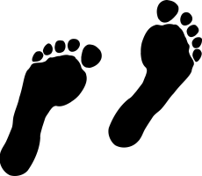
ECOLOGICAL FOOTPRINT PROJECT

For this multi-day library research project, you will create a product to show that you have grasped the concept of the Ecological Footprint and that you can apply this understanding to your own life.

Your product (what you hand in) should be one of the following:
- A dynamic google presentation, or a Weebly or Tumblr site, or a Powtoon, or
- A poster made from recycled materials (you will need to gather these on your own), or
- Another fabulous, creative idea that you come up with.
Over the next few days you will complete a checklist of work to be completed each day. If you finish your work before the end of the period, go ahead and move on to the next day’s tasks.

To help you with your research, I have created a list of web resources for you to review. Go to the course website and look for the EcoFootprint Resources tab:

Links to research sites: pattison2016.weebly.com

DAY ONE TASKS (Tuesday):

Gather research to answer the following questions – include a good amount of detail in your own words. Record your research either by hand or in a word document (that you will transfer on to your final product).

_____ What is an “Ecological Footprint”? Provide a definition in your
own words (not copied and pasted from elsewhere).

_____ What are the 7 areas that make up your Ecological Footprint?
(hint: see your Personal Ecological Footprint survey from Monday)

_____ How many Earths would we need if everyone on the planet lived
your quality of life? (see handout … or use an online quiz!)

_____ How big is the average Canadian’s Ecological Footprint (in hectares)?

_____ How does Canada’s average EF size compare to other countries?
(provide at least 3-4 other country’s EF – 1 bigger, and at least 2 smaller)

_____ Why is there a difference between the country sizes? Explain.

DAY TWO TASKS (Wednesday):

Continue to gather research for the following checklist items:

_____ What are some actions YOU can take as an INDIVIDUAL to reduce
your Ecological Footprint (EF) in at least 6 of the 7 EF areas?

_____ What are some actions YOUR FAMILY can take to reduce your EF in
at least 6 of the 7 EF areas?

_____ What are some actions ACTON HIGH SCHOOL can take to reduce its
EF in at least 6 of the 7 EF areas?

_____ Answer: Why is it important to live sustainably?

DAY THREE TASKS (Final Day – Thursday!):

Now, put all of your research together to form the final product that you will hand in to be marked. It should:

_____ Include a catchy title, slogan or message.

_____ Thoughtfully display all of the information you’ve gathered.

_____ Effectively use visuals (pictures) and colour. Cartoons are great too!

_____ Be in a format listed on the first page.

Be creative! It’s important that you don’t use new resources to create your project … use recycled materials. You can find cardboard at the back of the school (ask our janitor Kevin to help you find some).

**The evaluation ruby is on the course website.
Please review the ruby before you hand in your project.
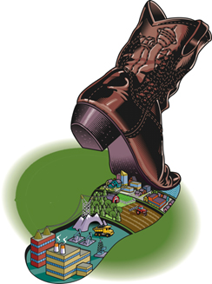

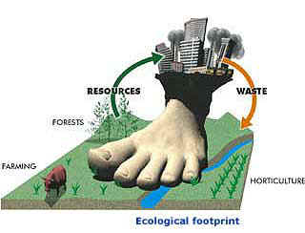
Due date: Start of class, Tuesday, March 29th

