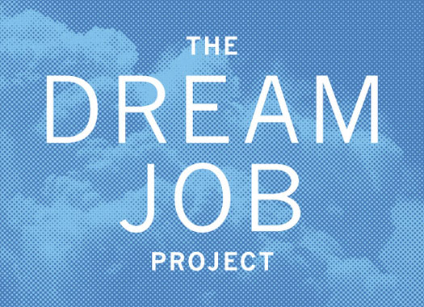
Task:
- Research your “dream job,” the education you will need to get (or pursue) the career of your dreams, how much it is going to cost per year, and how you are going to pay for it.
- To become familiar with the myBlueprint.ca website and create a profile.
Follow each part carefully and use the schedule given to you, and you will be successful!
-------------------------------------------------------------------------------------------------------------
First Step:
Select an occupation you are interested in. Make sure it is a realistic choice!
- To determine a good career for you, look back to your personality tests and the results in your Mini-Me Book.
- If you are having trouble deciding on one career, do some research on them, using the following websites:
*www.careercruising.com
*www.jobsetc.ca
*www.youth.gc.ca
*www.labourmarketinformation.ca/
* http://www.torontosun.com/2013/04/18/top-10-best-jobs-in-canada-and-how-to-land-them
c) Once you have chosen the occupation that fits you best, move on to “My
Dream Job Assignment: Step One.” Show me when you have completed it
and I will give you the next section.

NOTE: If you are stuck on one section, please ask for clarification. Google can also help you find answers to certain questions, as well as specific college/university websites.

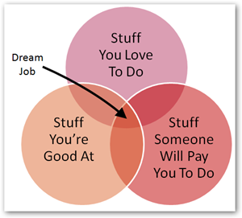
My Dream Job Assignment: Step One
Occupation Title: ______________________________________________________________________
List of Duties and Responsibilities: (Include at least 5 things that someone in your occupation has to do)

What is the work environment like? (Eg - indoor/outdoor, desk job, etc?)

Describe a typical work week: (Mon-Fri, 9-5, shift work, overtime, etc)

Transferable Skills (minimum of 5) Required: (These are skills that you need for this job that can be transferred to other jobs. Eg - communication skills, writing skills).

Technical Skills (minimum of 2) Required: (These are skills that are specific to your occupation. Eg - using a fire hose, creating computer software, etc.)

Use this website (http://www.workingincanada.gc.ca/) to find the answers for the following:
Are there many jobs in this field? What is the outlook?

Salary: What is the starting and top salary for your job?
My Dream Job Assignment: Step Two
EDUCATION
Use specific university/college websites to find the following. You may also use:
www.ontariocolleges.ca (college)
www.apprenticesearch.com (apprenticeship)
www.electronicinfo.ca (university)
www.myblueprint.ca
www.careercruising.com

What education is required for this occupation? (college/university/apprenticeship)

What is the name of the program? How long is the program?

List three schools that offer this program.

Choose ONE of the schools. What is their address, phone number, website and email address?

What are the admission requirements to get into your program? (required high school courses, average needed, audition, interview, etc)

What extra-curricular clubs/teams are offered at this school that interest you? (list 3-5)

My Dream Job Assignment: Step Three
MyBlueprint: Using www.myblueprint.ca (activation code is ________), input your course selections for all of high school and complete your profile (community service hours and action plan).
□ Create a chart of what courses you have taken in grade 9 and 10 (this should already be done for you). Add to this the courses you will need to take in grade 11 (8 courses) and grade 12 (minimum of 6 courses) to qualify for your post-secondary program. Don't forget to add grade 12 English!
□ Complete the profile section of the website:
□ Plan for volunteer hours
□ Goals and plan for action
□ Print all of these out when you have finished.

Part 4: Financial Plan
Create a financial plan that outlines how you intend on paying for your post-secondary education. Answer the following questions, using specific college/university websites and talking to your parents. Based on one year of study at your chosen school:
My financial plan:
Expenses | Cost (per month/year)
Tuition and fees
Accommodations (residence? Off campus? Living at home?)
Books and supplies
Entertainment (cable, cell phone, movies, etc.)
Transportation (car payment? Gas? Insurance? Bus pass?)
Food (residence meal plan? Eat at home?)
Living expenses (haircuts, laundry, etc.)
 | Total: $

How are you going to pay for post-secondary education? (parents, OSAP, savings account, live at home to save money, scholarships, work for a year to save money, etc.)
____________________________________________________________________________________________________________________________________________________________________________________________________________________________________________________________________
Step Five - Final Reflection:
Write a 250 word (minimum) reflection answering the following questions:
1. Why is it important to look ahead?
2. What have I learned from this assignment?
3. In order to succeed in achieving the path I have created, what are three goals I should set for myself for the next year? What are the actions I need to take to achieve my goals?

