Cultural Globalization Assignment
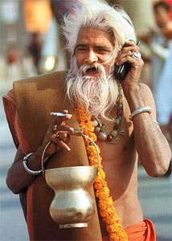

- Locate and display 3 photos that depict cultural globalization.
- Provide a detailed description of each photo: what are we looking at?
- What factors have led to the cultural globalization that we see in each?
- In a final paragraph... Identify and discuss the benefits of cultural diversity in the world.
Another way of looking at this is to consider:
what does the world lose with cultural homogenization?

3 photos show a breadth of understanding of cultural globalization.  /10 (Knowledge) | You have selected photos with some effectiveness | You have selected photos with limited effectiveness | You have selected photos with considerable effectiveness | You have selected photos with a high degree of effectiveness
Your detailed descriptions of each photo thoughtfully explain the context of cultural globalization.  /10 (Thinking) | Photo descriptions/ explanations are developed with some effectiveness | Photo descriptions/ explanations are developed with limited effectiveness | Photo descriptions/ explanations are developed with considerable effectiveness | Photo descriptions/ explanations are developed with a high degree of effectiveness
Your final paragraph highlights benefits of cultural diversity and what the world would lose with cultural homogenization.  /10 (Application) | Final paragraph explains with some effectiveness the benefits of cultural diversity and what the world would lose without it. | Final paragraph explains with limited effectiveness the benefits of cultural diversity and what the world would lose without it. | Final paragraph explains with considerable effectiveness the benefits of cultural diversity and what the world would lose without it. | Final paragraph explains with a high degree of effectiveness the benefits of cultural diversity and what the world would lose without it.
Overall spelling, grammar, clarity of thought.  /10 (Communication) | You communicate information with limited effectiveness | You communicate information with some effectiveness | You communicate information with considerable effectiveness | You communicate information with a high degree of effectiveness

