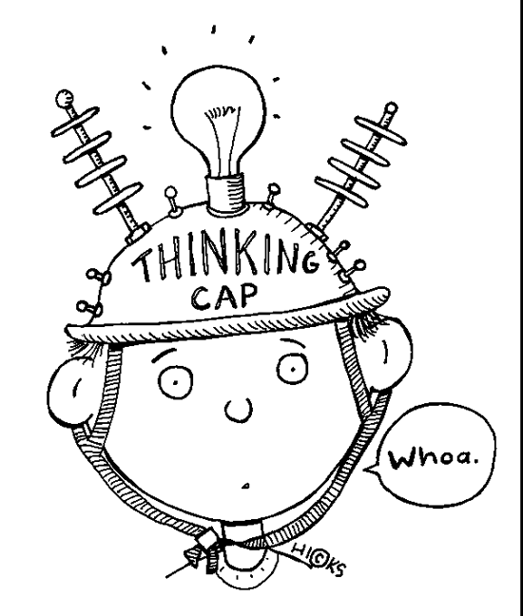
What Is COGNITIVE DISSONANCE?

People tend to seek consistency in their beliefs and perceptions. So what happens when one of our beliefs conflicts with another previously held belief? The term cognitive dissonance is used to describe the feeling of discomfort that results from holding two conflicting beliefs. When there is a discrepancy between beliefs and behaviors, something must change in order to eliminate or reduce the dissonance.

Cognitive = _______________________________________________________

Dissonance = ______________________________________________________
How exactly does cognitive dissonance work and how does it influence how we think and behave?

Psychologist Leon Festinger proposed a theory of cognitive dissonance centered on how people try to reach internal consistency. He suggested that people have an inner need to ensure that our beliefs and behaviors are consistent. Inconsistent or conflicting beliefs leads to disharmony, which people strive to avoid.
In his book A Theory of Cognitive Dissonance, Festinger explained, "Cognitive dissonance can be seen as an antecedent condition which leads to activity oriented toward dissonance reduction just as hunger leads toward activity oriented toward hunger reduction" (1957).

The amount of dissonance people experience can depend on a few different factors, including how highly we value a particular belief, and the degree to which our beliefs are inconsistent.
Cognitive dissonance can often have a powerful influence on our behaviors and actions. Let's start by looking at some examples of how this works.

Examples of Cognitive Dissonance
Cognitive dissonance can occur in many areas of life, but it is particularly evident in situations where an individual's behavior conflicts with beliefs that are integral to his or her self-identity. For example, consider a situation in which a person who places a value on being environmentally responsible just purchased a new car that they later discover does not get great gas mileage.

The conflict:
- It is important for the person to take care of the environment.
- They are driving a car that is not environmentally-friendly.

In order to reduce this dissonance between belief and behavior, they have a few difference choices. They can sell the car and purchase another one that gets better gas mileage, or they can reduce their emphasis on environmental-responsibility. In the case of the second option, their dissonance could be further minimized by engaging in actions that reduce the impact of driving a gas-guzzling vehicle, such as utilizing public transportation more frequently or riding their bike to work on occasion.

Another example:
- "The person who continues to smoke, knowing that it is bad for her/his health, may also feel (a) s/he enjoys smoking so much it is worth it; (b) the chances of his health suffering are not as serious as some would make out; (c) s/he can't always avoid every possible dangerous contingency and still live; and (d) perhaps even if s/he stopped smoking he would put on weight which is equally bad for his health. So, continuing to smoke is, after all, consistent with his ideas about smoking."
(Festinger, 1957)
The ancient fable of The Fox and The Grapes is commonly used as example of cognitive dissonance. The fox wants to eat the grapes, but he can't reach them. These two feelings are in conflict: Want grapes, can't have them. In order to reduce this discomfort, the fox rationalizes "The grapes are probably sour anyway."

How to Reduce Cognitive Dissonance
There are three key strategies to reduce or minimize cognitive dissonance:
- Focus on more supportive beliefs that outweigh the dissonant belief or behavior
- Reduce the importance of the conflicting belief
- Change the conflicting belief so that it is consistent with other beliefs or behaviors

Why is Cognitive Dissonance Important?
Cognitive dissonance plays a role in many value judgments, decisions and evaluations. Becoming aware of how conflicting beliefs impact the decision-making process is a great way to improve your ability to make faster and more accurate choices.

Let’s apply this theory to the context of Prom Night in Mississippi:

1. Describe in detail (in writing) how cognitive dissonance might look/feel like for:
- (some) White students who did not attend the ‘White prom’ and but did attend the integrated prom;
- (some) Parents of White students whose daughter/son attended both proms (the ‘White prom’ and integrated prom);
- Parents who did not allow their White daughter/son to attend the integrated prom, even though their daughter/son wanted to go to it;
- The father of the White female student dating the Black male student.

2. What social change are we seeing take place in the documentary? Don’t be simplistic in your response. Identify and describe all of the actors involved to make this social change possible.
3. Who is in favour of the social change? Who is resistant? Why? Try to see the situation from both sides.
4. How is cognitive dissonance related to social change?
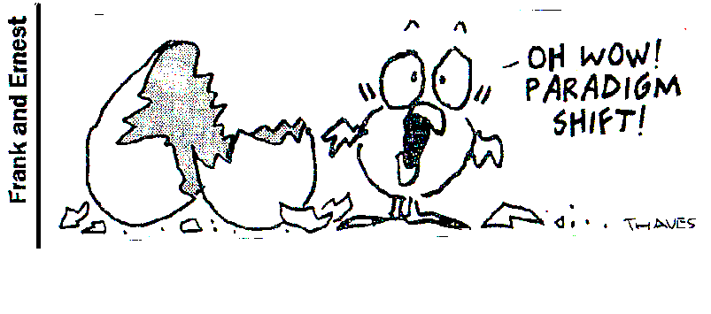
4. Describe a situation when you have experienced cognitive dissonance. How did/do you rectify the dissonance?
5. Can cognitive dissonance result in a paradigm shift?

References:

Cherry, K. (n.d.). What Is Cognitive Dissonance? Retrieved February 15, 2014 from
http://psychology.about.com/od/cognitivepsychology/f/dissonance.htm

Festinger, L. (1957). A Theory of Cognitive Dissonance. Chicago: Stanford University Press.

