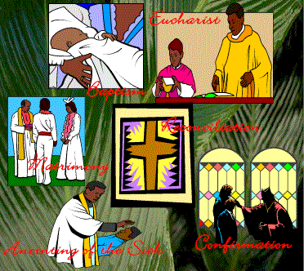
Christianity Rituals:
Rites of Passage
Religious events can mark important stages in life. Christianity bestows sacraments upon individuals when they reach these stages, to identify a new beginning. There is a great variety in the recognition of sacraments among Christians, and there are some branches of Christianity that do not include sacraments as part of their religious practices. Both the Eastern Orthodox and Roman Catholic Churches both celebrate 7 sacraments to mark the passage of life. Summarize each (in your own words!) from your textbook, pp. 284-289.

Sacrament | Why? | Describe what happens:
Baptism |  | Human needs met:
Holy Communion  (Eucharist)  Transubstantiation Definition: |  | Human needs met:
Confession |  | Human needs met:
Chrismation or Confirmation |  | Human needs met:
Matrimony |  | Human needs met:
Anointing the Sick or Dying

Funerals

1. Which Christian milestones often use the rituals indicated below?

a) cleansing with water:

b) anointing with oils:

c) laying on of hands:

2. Can you discuss the meaning of the following terms? sacrament, original sin, transubstantiation

