An overview of sociology, psychology, and anthropology:

Discipline / Field of Study | ‘Definition’ | Fundamental Questions | Fundamental Beliefs
Sociology  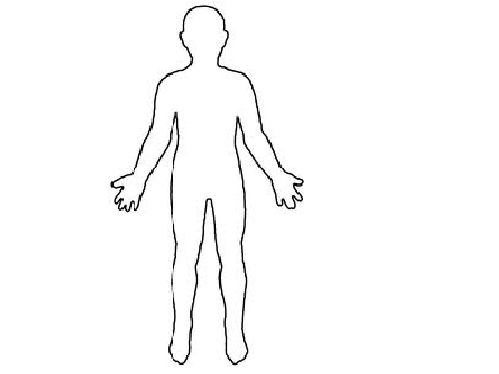 | “a highly structured system of human organization for large-scale community living that normally furnishes protection, continuity, security, and an identity for its members” | How am I shaped by my surroundings?  How do individuals learn and adapt to the specific rules and modes of behaviour that govern the group?  What is deemed ‘normal’ and how should ‘abnormality’ be ‘dealt with?’  What social problems exist and how can they be overcome? | The groups to which an individual belongs will determine the roles and expectations that s/he/they will value and emulate in her/his/hir private life.  Societies function because people sacrifice some of their freedom in order to have a functional society.
Psychology | The study of the human mind, behaviours, emotions, cognitive processes and personality.  Social Psychology  Clinical Psychology  (learning/cognitive theories) | Why do humans behave as they do?  How does personality develop?  What is intelligence?  How can we control our emotions? (can we?) | Behaviour is both learned and innate. Both factors influence and shape how individuals will behave, feel, act, or respond to external stimuli.
Anthropology  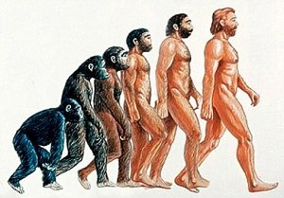 | Cultural Anthropology:  Examines and compares cultures... where culture is any behaviour that is transmitted from 1 person to another.  Physical Anthropology:  Examines evolution of humankind ... and maybe lots of ‘digging for answers’... | How was human culture developed?  What symbols do cultures share?  What material objects do we possess or desire?  What is ‘beauty’? How does this differ between cultures?  How was language established? | “The purpose of anthropology is to make the world safe for human differences.”  (Ruth Benedict)  Understanding our origins will help explain how we live, communicate, and interact with our environment.

Discipline / Field of Study | How can we relate each to ...  Sex education curriculum
Sociology

Psychology

Anthropology

