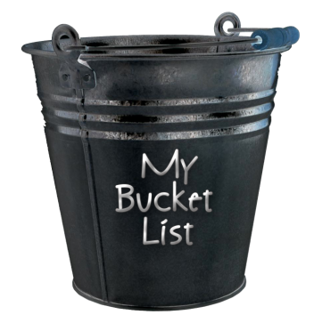
THE BUCKET LIST ASSIGNMENT

If you haven’t heard about the bucket list, it is a wish list of all the goals you want to achieve, dreams you want to fulfill and life-experiences you desire to experience before you die.
Part One- Paragraph

You are in high school. In just a couple of years, you will be out of high school. Oh my!

What I want you to do is think about that. Think about 10 years from now. What I want you to do is write down where you see yourself in 10 years.

In a paragraph or two, answer these “What do you want to be when you ‘grow up’” questions.

- What do you want to be doing in 10 years?
- What type of career will you have?
- Where do you think you will live?
- What job(s) are you certain that you DON’T want to do?
- Would you work at a job you didn’t like if it paid you more money?
- Would you want a job that is the same every day?
- Would you want a job in which two days are never the same?

Part Two: The Bucket List:

Now, we need to really think about the “Big Picture.” Think forward to when you are 95 years old (Ms. Pattison’s age), sitting on your porch swing, (or if you don’t like swings, a chair), and you are reflecting on your life.

What is on your “Bucket List” that you will be thinking about while sitting on your porch? Using google doc, put together at least 30 items that you want to do before you kick the bucket?

These items need to be divided into the following categories:

  - Things to improve me professionally (skills), emotionally and personally.
  - Things to just have fun or “I’ve always wanted to do it”.
  - Things that involve others.

In order to complete this assignment you must use a google doc presentation. Here is a suggestion for organizing your slides:

- Title page (include somewhere ‘My Bucket List’)
- Part 1 – paragraph response (you may need more than 1 slide)
- Bucket list items: (Things to improve me professionally...)
- Bucket list items: (Things to just have fun or ...)
- Bucket list items: (Things that involve others...)

3. The google doc presentation:

 | Level 1 | Level 2 | Level 3 | Level 4
Application  ( /10) | Your Bucket List lacks items; they are not categorized. | There are items in categories but they are not complete. | There’s 30 items but they are vague and unspecific. IE: “I want to learn stuff.” | Your Bucket list items are unique AND specific. They fit the required categorical requirements. It looks like you cared.
Communication  ( /10) | A basic google doc | A basic google doc… looking a bit schnazier | A google doc with some of your own personal touches and pics | A google doc with personal touches that makes the presentation more about you a boring ol’presentation. It includes, pics, videos shows you experimented with the program.

