Behaviorism (in psychology)
By Saul McLeod, published 2007 (Updated 2013)
Behaviorism (also called the behaviorist approach) was the primary paradigm in psychology between 1920s to 1950 and is based on a number of underlying assumptions regarding methodology and behavioral analysis:
* Psychology should be seen as a science. Theories need to be supported by empirical data obtained through careful and controlled observation and measurement of behavior. Watson stated that “psychology as a behaviorist views it is a purely objective experimental branch of natural science. Its theoretical goal is … prediction and control” (1913, p. 158).
* Behaviorism is primarily concerned with observable behavior, as opposed to internal events like thinking and emotion. Observable (i.e. external) behavior can be objectively and scientifically measured. Internal events, such as thinking should be explained through behavioral terms (or eliminated altogether).
* People have no free will – a person’s environment determines their behavior
* When born our mind is 'tabula rasa' (a blank slate).
* There is little difference between the learning that takes place in humans and that in other animals. Therefore research can be carried out on animals as well as humans.
* Behavior is the result of stimulus – response (i.e. all behavior, no matter how complex, can be reduced to a simple stimulus – response association). Watson described the purpose of psychology as: “To predict, given the stimulus, what reaction will take place; or, given the reaction, state what the situation or stimulus is that has caused the reaction” (1930, p. 11).
* All behavior is learnt from the environment. We learn new behavior through classical or operant conditioning.
The psychodynamic approach (Freud) criticizes behaviorism as it does not take into account the unconscious mind’s influence on behavior, and instead focuses on external observable behavior. Freud as rejects that idea that people are born a blank slate (tabula rasa) and states that people are born with instincts (e.g. eros and thanatos).
Biological psychology states that all behavior has a physical / organic cause. They emphasize the role of nature over nurture. For example, chromosomes and hormones (testosterone) influence our behavior too, in addition to the environment.

Despite these criticisms behaviorism has made significant contributions to psychology. These include insights into learning, language development, and moral and gender development, which have all been explained in terms of conditioning. The contribution of behaviorism can be seen in some of its practical applications. Behavior therapy and behavior modification represent one of the major approaches to the treatment of abnormal behavior and are readily used in clinical psychology.

Pavlov's Dogs
Like many great scientific advances, classical conditioning was discovered accidentally.
During the 1890s Russian physiologist Ivan Pavlov was looking at salivation in dogs in response to being fed, when he noticed that his dogs would begin to salivate whenever he entered the room, even when he was not bringing them food. At first this was something of a nuisance (not to mention messy!).

Pavlovian Conditioning
Pavlov (1902) started from the idea that there are some things that a dog does not need to learn. For example, dogs don’t learn to salivate whenever they see food. This reflex is ‘hard wired’ into the dog. In behaviorist terms, it is an unconditioned response (i.e. a stimulus-response connection that required no learning). In behaviorist terms, we write:
Unconditioned Stimulus (Food) > Unconditioned Response (Salivate)
Pavlov showed the existence of the unconditioned response by presenting a dog with a bowl of food and measuring its salivary secretions (see image below).
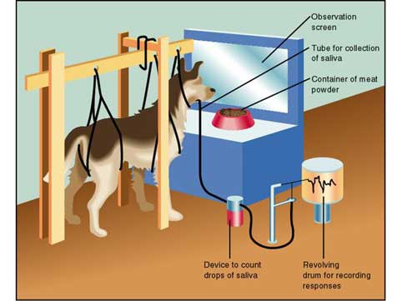
However, when Pavlov discovered that any object or event which the dogs learnt to associate with food (such as the lab assistant) would trigger the same response, he realized that he had made an important scientific discovery, and he devoted the rest of his career to studying this type of learning.
Pavlov knew that somehow, the dogs in his lab had learned to associate food with his lab assistant. This must have been learned, because at one point the dogs did not do it, and there came a point where they started, so their behavior had changed. A change in behavior of this type must be the result of learning.
In behaviorist terms, the lab assistant was originally a neutral stimulus. It is called neutral because it produces no response. What had happened was that the neutral stimulus (the lab assistant) had become associated with an unconditioned stimulus (food).
In his experiment, Pavlov used a bell as his neutral stimulus. Whenever he gave food to his dogs, he also rang a bell. After a number of repeats of this procedure, he tried the bell on its own. As you might expect, the bell on its own now caused an increase in salivation.
So the dog had learned an association between the bell and the food and a new behavior had been learnt. Because this response was learned (or conditioned), it is called a conditioned response. The neutral stimulus has become a conditioned stimulus.
Pavlov found that for associations to be made, the two stimuli had to be presented close together in time. He called this the law of temporal contiguity. If the time between the conditioned stimulus (bell) and unconditioned stimulus (food) is too great, then learning will not occur.
Pavlov and his studies of classical conditioning have become famous since his early work between 1890-1930. Classical conditioning is "classical" in that it is the first systematic study of basic laws of learning / conditioning.

Summary
To summarize, classical conditioning (later developed by John Watson) involves learning to associate an unconditioned stimulus that already brings about a particular response (i.e. a reflex) with a new (conditioned) stimulus, so that the new stimulus brings about the same response.
Pavlov developed some rather unfriendly technical terms to describe this process. The unconditioned stimulus (or UCS) is the object or event that originally produces the reflexive / natural response.
The response to this is called the unconditioned response (or UCR). The neutral stimulus (NS) is a new stimulus that does not produce a response.
Once the neutral stimulus has become associated with the unconditioned stimulus, it becomes a conditioned stimulus (CS). The conditioned response (CR) is the response to the conditioned stimulus.
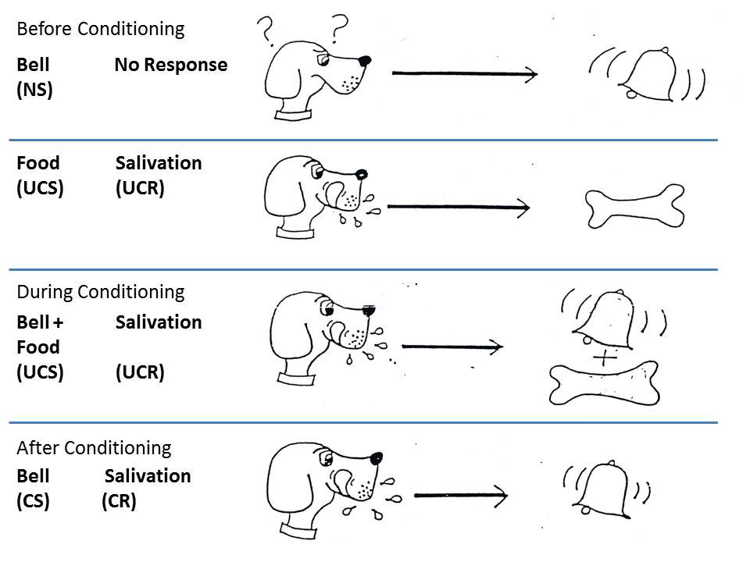

Little Albert Experiment (Phobias)

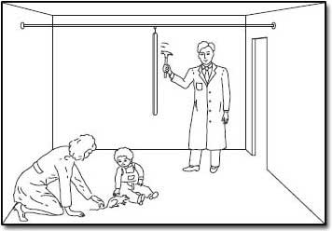
Ivan Pavlov showed that classical conditioning applied to animals. Did it also apply to humans? In a famous (though ethically dubious) experiment John B. Watson and (1920) showed that it did.

Little Albert was a 9-month-old infant who was tested on his reactions to various stimuli. He was shown a white rat, a rabbit, a monkey and various masks. Albert was described as "on the whole stolid and unemotional" and showed no fear of any of these stimuli. However what did startle him and cause him to be afraid was if a hammer was struck against a steel bar behind his head. The sudden loud noise would cause little Albert to burst into tears.
When "Little Albert" was just over 11 months old when the white rat was presented and seconds later the hammer was struck against the steel bar. This was done 7 times over the next 7 weeks and each time "little Albert" burst into tears. By now little Albert only had to see the rat and he immediately showed every sign of fear. He would cry (whether or not the hammer was hit against the steel bar) and he would attempt to crawl away.
Watson had shown that classical conditioning could be used to create a phobia. A phobia is an irrational fear, i.e. a fear that is out of proportion to the danger. Over the next few weeks and months "Little Albert" was observed and 10 days after conditioning his fear of the rat was much less marked. This dying out of a learned response is called extinction. However even after a full month it was still evident.

Reading/ Response Questions:
1. What, according to Behavorism, should be the focus of psychology?

2. In your own words, explain 3 limitations (and/or) criticisms of Behaviorism.

3. Do you dis/agree with Behaviorism’s underlying assumption that humans are born with tabula rasa? (consider Freud’s argument) Explain.

4. What word/term could be substituted for ‘conditioning’?

5. Provide 3 examples of unconditioned stimulus > unconditioned response in humans (drawing from your own experiences would be helpful).

6. Provide 3 examples of conditioned stimulus > conditioned response in humans.

(remember: the conditioned stimulus is a previously neutral stimulus that, after becoming associated with the unconditioned stimulus, eventually comes to trigger a conditioned response).

7. Was Dr. Watson’s experiment(s) with Little Albert ‘ethical’? Explain why, or why not.

8. There is a need for teachers to try to ensure that students associate positive emotional experiences with learning. If a student associates negative emotional experiences with school then this can obviously have bad results … such as creating a school phobia.
What are 3 examples of a ‘school phobia’? What conditioning could/would have led to these?

