WAYS IN WHICH HINDUS EXPRESS THEIR FAITH:
PRACTICES, RITUALS, AND SYMBOLS
Pages 129-135

A Hindu lives her or his religion through worship rituals that have been transmitted from one generation to another. Hindus worship in many different ways, and there is no standard form. Daily worship takes place mainly at home; going to the temple for prayer is not absolutely necessary. A Hindu child learns about the religion and its festivals by observation and by taking part in rituals at home.
Many Hindus begin their day with some kind of religious ritual, for example, greeting the sun; others perform their rituals in the evenings or on weekends. Most Hindus purify themselves with water before participating in a religious ritual, usually by taking a bath.

(i) What does ‘om’ represent to Hindus? (see pages 129 & 133)
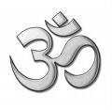

(ii) The swastika is another important symbol in Hinduism. What does it mean and when is it used? (page 133)
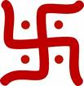

(iii) Describe how a Hindu might worship in their home? In your vivid description, include the terms: shrine, deities, puja, offerings, arati, Prasad. (page 130)

(iv) From the textbook and accompanying article, explain the significance of the cow Hinduism. (page 131)
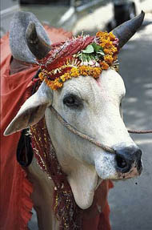

(v) Yoga is very much a part of our society these days. How does our practice of Yoga in North America differ from Yoga as understood by Hindus? (page 131)

(vi) What is a pilgrimage? Why do many Hindus strive to visit, at least once in their lifetime, the city of Varanasi? (page 131)

(vii) Why do you think there are so many Hindu festivals? Provide a brief description of one festival that sparks your interest. (pages 134-135)

