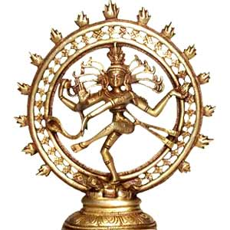
DHARMA
Hindus refer to their religion as dharma, which means code of moral and righteous duty. The concept of dharma pertains to the duties and responsibilities of the individual, and it is considered essential to the welfare of the individual, the family, and society.
Varnashrama dharma concerns the specific duties of each individual with respect to age, sex, and status in society.

(ii) Four Aims or Goals in Life
From page 126 of your text, briefly discuss in your own words each of the goals that constitute the Hindu personal value system. Each incorporates her or his material desires and spiritual needs.

Dharma

Artha

Kama

Moksha

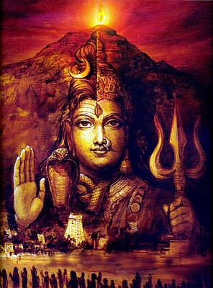
(i) The Four Paths to Salvation

In Hinduism, there are four paths to salvation (moksha). The path a Hindu chooses to follow generally depends on her or his nature and personality. Each path can lead to salvation if the follower is sincere.
In the left side of the chart, summarize how each path strives to achieve salvation in your own words (see page 124 in your textbook). On the right of the chart, identify the path that would most appeal to you as a Hindu, and explain why. Also, indicate which one would least appeal to you as a Hindu, and why.

Bhakti Yoga (Path of Devotion)

Karma Yoga (Path of Action)

Jnana Yoga (Path of Wisdom)

Raja Yoga (Path of Meditation)

