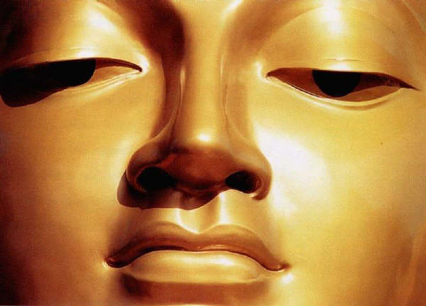
THE LIFE OF THE BUDDHA: SIDDHARTHA GAUTAMA

Read ALL of pages 162-168 (but not 166) to learn about the life of Siddhartha Gautama: the Buddha. Don’t skim and scan ... read!

1. Describe the circumstances of Siddhartha’s conception and birth in your words.
________________________________________________________________________________________________________________________________________________________________________________________________________________________________________________________________________________________________________________________

2. Identify and explain the Four Sights Siddhartha experienced when he visited the city four times from his palace.

(i) ___________________________________________________________________________

(ii) ___________________________________________________________________________

(iii) __________________________________________________________________________

(iv) __________________________________________________________________________

3. Why were these four sights so important to Siddhartha? How did they influence his thinking?
________________________________________________________________________________________________________________________________________________________________________________________________________________________________________________________________________________________________________________________

4. Explain the significance of the Middle Way (sometimes referred to as the Middle Path).
________________________________________________________________________________________________________________________________________________________________________________________________________________

5. Explain the difference between attaining enlightenment, and achieving nirvana (p. 165). The glossary may provide a clearer understanding for you than the text reading.
________________________________________________________________________________________________________________________________________________________________________________________________________________
____________________________________________________

6. Which aspects of Hinduism did the Buddha accept? (pages 167-168)
________________________________________________________________________________________________________

7. Give four aspects of Hinduism Siddhartha rejected. Explain why he disagreed with each. (pages 167-168)

(i)

(ii)

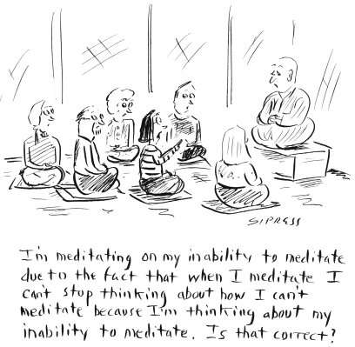

(iii)

(iv)

