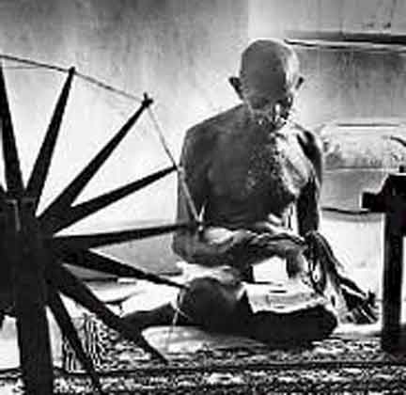
Gandhi:

Understanding the man and Deciphering the Significance of his Quotes

Gandhi is one of the most quoted people on the planet. But why? What is the meaning behind his words? How are these quotes rooted in Hindu beliefs?

Called one of the most influential figures of the twentieth century, Mahatma Gandhi used his strong Hindu roots to propel him in his quest for India home rule (freedom from the British). Peaceful, proactive, and highly educated, he wanted the spiritual nature of Hinduism to be used for good. He was guided by the teachings of the Bhagavad-Gita (Hindu scripture), and demonstrated tolerance and admiration for many other religions.

He was guided by 2 philosophies, both rooted in Hinduism: Ahimsa and Satyagraha

Ahimsa:______________________________________________________________

Satyagraha: __________________________________________________________

Your task is to study this man, and create some sort of presentation to explain 3 of his most recognizable and meaningful quotes to an ignorant audience.

On the back of this sheet are several quotes from Gandhi to help your thinking.

You will:

- Choose 3 significant quotes for which he is remembered. Clearly explain the meaning behind each and the context in which they were used.
- Using some sort of presentation format, formulate a well-constructed explanation for each quote that discusses not only the event surrounding the quote, but also why it was significant to Gandhi, his cause, and his legacy.
- Your work should explain the term AHIMSA and SATYAGRAHA.
- Type out an APA bibliography

Quotes from “Gandhi”
(This list is incomplete! Seek out more!)

“You must be the change you want to see in the world.”

“An eye for an eye only ends up making the world blind.”

You must not lose faith in humanity. Humanity is an ocean; if a few drops of the ocean are dirty, the ocean does not become dirty.

“I know a way out of Hell. Find an orphan boy, a Muslim, and raise him as your own. Only be sure to raise him as a Muslim.” (Said to a Hindu man who had killed a Muslim child in the riots).

“Humility and simple truth are more powerful than empires.”

“Love thy neighbour as thyself – all the religions come down to the same thing.”

“If you are a minority of one, the truth is still the truth.”

“How do we treat men who defy an unjust law but do not fight?”

“Where we see injustice do we fight to change things or fight to punish?”

“At temple as a little boy, it mattered not which holy book was being read as long as God was being worshipped.”

“I am a Muslim, a Hindu, a Jew, a Christian. When you wave those flags you send fear into the hearts of your brothers – that is not what I want. Stop it.”

“The only devils are the ones running around in our own hearts.”

“The way of truth and love has always won – there are tyrants who may seem invincible but in the end they always fall. Always.”

