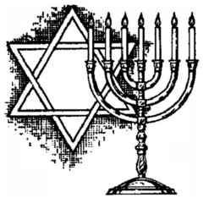
MISCONCEPTIONS QUIZ - JUDAISM

- Judaism is by far one of the smallest world religion. Fact or fiction?

- Judaism teaches that the messiah has come, however, Jews are the only people that recognize this belief. Fact or fiction?

- There are no Jews in Canada. Fact or fiction?

- A Jewish place of worship is called a mosque. Fact or fiction?

- Moses is an important figure in Judaism. Fact or fiction?

- Judaism teaches that Jesus was a liar. Fact or fiction?

- Jewish tradition teaches that God is all-powerful. Fact or fiction?

- Keeping kosher means that Jews can only eat at a certain time of the day. Fact or fiction?

- Jews celebrate Christmas. Fact or fiction?

- The Holocaust claimed the lives of 6 million Jews. Fact or fiction?

Why do you feel there are so many misconceptions about Judaism?
Explain why you feel so little is truly understood by outsiders to this religion.
JUDAISM QUESTIONS#1
Read pp.216-218 of your text

- What do you think Abraham’s life was like before he received his vision.

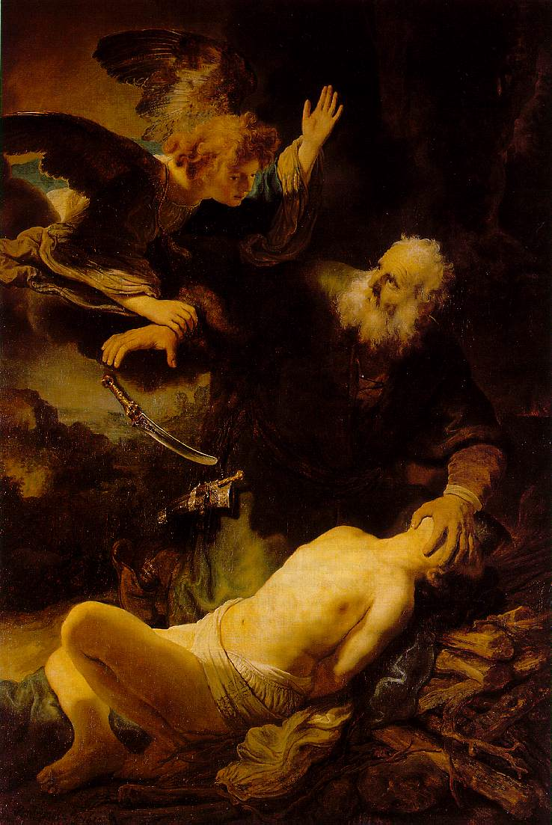
- In your own words, explain what God instructed Abraham to do.

3. Where is the Canaan located on a modern map of the world?

- Contextually explain the following terms from the reading:
  - Chosen people
  - Promised land
  - Covenant

