WHAT HAVE WE LEARNED FROM DANTE’S PEAK?
WARNING THE CITIZENS OF KAWA-GUCHIKO, JAPAN
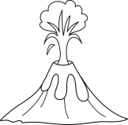

You are one of the few surviving citizens of Dante’s Peak! You and your family witnessed the terror of the mountain and the deathly fallout of what happened. You now understand that you should have read the signs and listened to the geologists’ warnings. You know what can happen when people ignore the signs of impending DOOM.

The citizens of Kawa-guchiko, Japan live in the shadow of the dormant volcano Mount Fuji. Many of the residents are aware that at any time, their sleeping volcano could awake violently. As a survivor of the Dante’s Peak volcano, you now feel it is your duty to teach the people of Kawa-guchiko about the warning signs they should be on the lookout for leading to a disaster, and what might happen as a result.

Your task is to create a warning flyer (using google docs) that you will post around the town of Kawa-guchiko. On your flyer, you must include the following information:

_____ An eye-catching title.
_____ A list of 10 warning signs that something may be stirring in the volcano.
_____ A step-by-step description of the events of a volcanic eruption (include 5 steps).
_____ Explain what a pyroclastic explosion is and how it could devastate their town.
_____ At least 3 photos to illustrate your own geological survivor experience.
_____ Include your name on the bottom right corner of the flyer.
_____ Review the evaluation rubric to make sure you’ve completed everything.
_____ Share the flyer to your teacher, Ms. Pattison (pattisonmej@hdsb.ca)

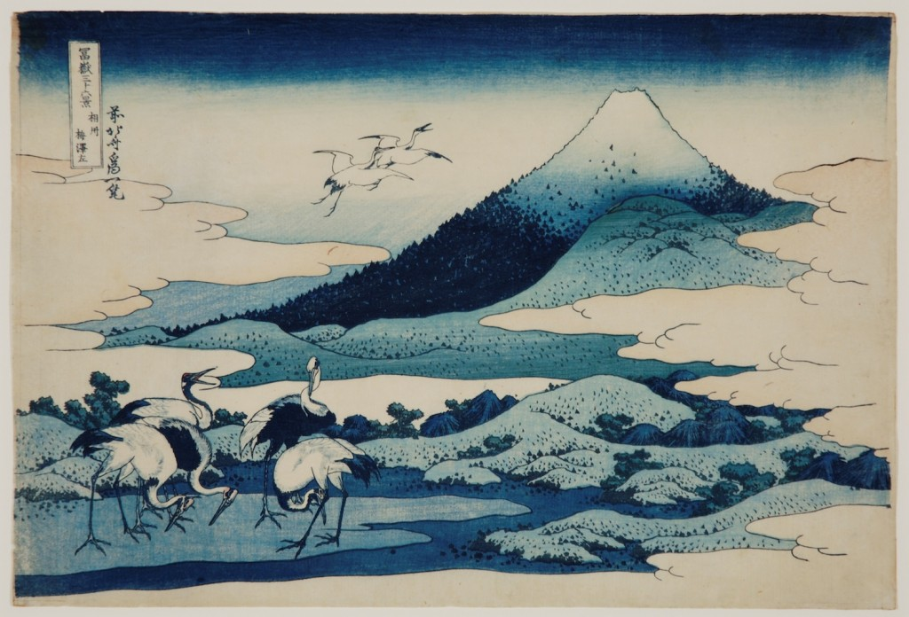
Evaluation Rubric Your Name: ___________________
What do I  need to do? | Level 4 | Level 3 | Level 2 | Level 1
Your flyer includes appropriate geographic terms and concepts from the film  Knowledge  _____ / 10 | The flyer shows exceptional understanding of geographic terms and concepts from the film. | The flyer shows considerable understanding of geographic terms and concepts from the film. | The flyer shows some understanding of geographic terms and concepts from the film. | The flyer shows a limited understanding of geographic terms and concepts from the film.
Your flyer provides appropriate and sufficient evidence from your own experience to support your warning of a geologic disaster  (e.g. you list the steps leading up to the eruption, and what happened after)  Application  _____ / 10 | Your flyer provides exceptional evidence from your own experience to support your warning of a geologic disaster | Your flyer provides considerable evidence from your own experience to support your warning of a geologic disaster | Your flyer provides some evidence from your own experience to support your warning of a geologic disaster | Your flyer provides limited evidence from your own experience to support your warning of a geologic disaster
Your flyer effectively communicates the information to the people of Japan.  Your flyer:  - is well organized  - has an appropriate title that grabs the attention of the reader  - uses effective and relevant photos  Communication  _____ / 10 | Your flyer communicates the information to the people of Japan with an exceptional degree of effectiveness. | Your flyer communicates the information to the people of Japan with a considerable degree of effectiveness. | Your flyer communicates the information to the people of Japan with some degree of effectiveness. | Your flyer communicates the information to the people of Japan with limited degree of effectiveness.

TOTAL MARK: _____ / 30 _____%

