Map Projections

A map projection is made when:

________________________________________________________________________

Have a look at the map on the flip side. This map represents a very famous projection: the Mercator projection.

1. On this map, locate, label, and shade the following 8 countries in pencil:

Greenland, Canada, Brazil, India, Saudi Arabia, Argentina, Algeria, Sudan

2. In the first column below, check to make sure the countries are correctly ranked by size from largest to smallest according to how they appear on your map.

3. Using the atlas (pp. 176-183) find the actual area of each country. Record this in the second column below.

4. Now, rank each country by area in the last column, from largest to smallest.

5. Finally, compare your ranking of the countries in the first column to the actual area ranking in the third column. What differences do you notice?
____________________________________________________________________________________________________________________________________________________________

Rank by Size  (which looks biggest) | Actual Area  (thousand km2) | Ranked by Area
1. Greenland
2. Canada
3. Brazil
4. Argentina
5. Algeria
6. Sudan
7. India
8. Saudi Arabia

Map Projections – Part 2

So what have we learned from this activity?

Well, EVERY MAP contains unavoidable __________________________.

On some maps, parts of the earth may appear larger or smaller than in reality.

On others, the shapes of the land masses are _______________, and sometimes compass directions are ____________________.

__________________________Projection

- Is well suited for navigation charts because it gives true compass bearing between points.
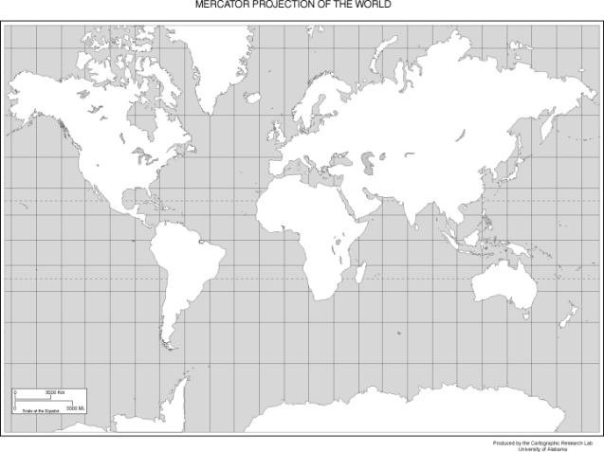
- However, it greatly distorts the size of land masses and ocean areas. Countries near the equator appear ____________, while those at the poles appear ____________.

__________________________Projection

- Developed in 1998 by the National Geographic Society.
- A map projection that shows the correct size of countries in relation to one another.
- An equal-area projection.
