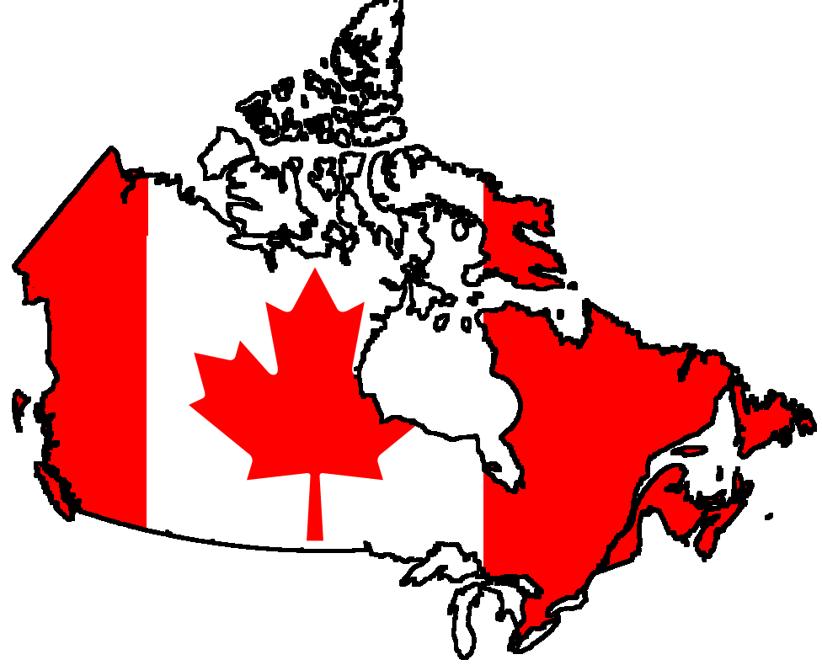
POLITICAL MAP OF CANADA

Aha! Did you forget this was a geography course and that you may be expected to work on things like ... maps? ... or know where things are in the world? ... and in relation to each other?? Well then, it’s your lucky day! Complete the following:

1. Provide an appropriate and creative title and place it at the top of your map. Use UPPER CASE LETTERS and underline your title. Write your name in the lower left corner of the map.

2. Neatly label the following provinces and territories using UPPER CASE LETTERS. Be sure the lettering is neat, level, and of appropriate size.

Ontario Manitoba Quebec
Newfoundland Nunavut Prince Edward Island
Saskatchewan New Brunswick Nova Scotia
Yukon Northwest Territories British Columbia
Alberta

3. Neatly label the following provincial and territorial capitals on the map using lower case lettering (Capitalize the first letter). Use a small dot . to indicate the location of the city. Be sure the lettering is neat, level, and of appropriate size.

Victoria St. John’s Fredericton
Toronto Winnipeg Charlottetown
Yellowknife Regina Iqaluit
Halifax Edmonton Whitehorse
Quebec City

4. Label the following water bodies on the map using lower case lettering (Capitalize the first letter). Be sure the lettering is neat, level, and of appropriate size.

Arctic Ocean Beaufort Sea Hudson Bay
Pacific Ocean Labrador Sea All 5 Great Lakes
Baffin Bay

5. Shade all of the major shorelines of water blue.

6. Oh... I almost forgot! Please remember where all the place locations are because you’ll be having a quiz on them this Friday. Yay!

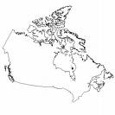Canada Map Evaluation

Name: _______________________ Date: _____________________

Criteria | Level 4 | Level 3 | Level 2 | Level 1 | Marks Assigned
Content  (knowledge) | All place names and titles are:  - included  - spelled correctly | All place names and titles are:  - included  - with few spelling mistakes | Some place names and titles are:  - not included  - spelled incorrectly | Many place names and titles are:  - not included  - spelled incorrectly | / 5
Accuracy of Features Mapped  (knowledge) | Features are  - mapped with a great deal of accuracy  - 0 to 1 errors | Features are  - mapped with consistent accuracy  - 2 to 3 errors | Features are  - mapped with moderate accuracy  - 4 to 5 errors | Features are  - mapped with limited accuracy  - more than 5 errors | / 5
Lettering  (communication) | All lettering is  - very neat  - level  -appropriate font/size  - written as per instructions | All lettering is  - neat  - somewhat level  -appropriate font/size  - written as per instructions | Some lettering is  - messy  - uneven  -inappropriate  font/size  - with some style  - some lettering not per instructions | Most lettering is  - messy  - uneven  -inappropriate  font/size  - lacking style  - some lettering not per instructions | / 10

Mark: _____ / 20 = _____ %

